Virtual Data Science with Python Apprentice Intern
Week 2 Report
Advanced Data Visualization and Storytelling
Data story: Who survived the Titanic, and why?
Tools: Python, Pandas, Seaborn, Matplotlib
Prepared by: Vandana

1. Introduction
In Week 1 the Titanic passenger data was cleaned and explored. This week the goal is different: to turn that data into a story that a non-technical reader can follow. Instead of showing every possible chart, each visualization here answers one question and hands over to the next, so that the six charts read as one narrative rather than a collection of plots.
The story is built around a single question: who survived the Titanic, and why? It unfolds in six steps:
- Who? Survival by sex, the biggest single divide in the data.
- Where on the ship? How ticket class combined with sex.
- How old? Whether children were protected.
- With whom? Whether family size helped or hurt.
- How much did they pay? Fare differences between survivors and non-survivors within each class.
- Putting it together. A single heatmap combining class and age.
The intended audience is a general reader with no statistics background. For that reason chart titles state the finding in plain language, values are written directly on the charts, and group sizes are shown wherever a small group could mislead.

2. Methods

2.1 Data and preparation
The dataset is the same Kaggle Titanic file used in Week 1 (891 passengers, 12 columns). The same cleaning steps were repeated so that this report stands on its own: missing ages were filled with the median (28.0), the two missing ports of embarkation with the most common port (S), the Cabin column was dropped because about 77% of it was missing, and no duplicate rows were found.

2.2 Features created for the story
Raw numbers such as age in years are hard to read in a chart, so several columns were converted into simple groups. Readable labels were also added (for example, “1st class” instead of 1).
New column | How it was built | Purpose
Outcome | Survived: 0 → “Did not survive”, 1 → “Survived” | Readable chart legends
Class | Pclass: 1, 2, 3 → “1st class”, “2nd class”, “3rd class” | Readable axis labels
AgeGroup | Age cut into Child (0–12), Teen (13–18), Young adult (19–35), Adult (36–60), Senior (61+) | Shows age effects without a crowded axis
FamilySize | SibSp + Parch + 1 (the passenger plus relatives aboard) | Measures who travelled with family
FamilyGroup | FamilySize cut into Alone, Couple (2), Small family (3–4), Large family (5+) | Compares family situations

df = pd.read_csv('Titanic-Dataset.csv')
df['Age'] = df['Age'].fillna(df['Age'].median())
df['Embarked'] = df['Embarked'].fillna(df['Embarked'].mode()[0])
df = df.drop(columns=['Cabin']).drop_duplicates()

# Readable labels
df['Outcome'] = df['Survived'].map({0: 'Did not survive', 1: 'Survived'})
df['Class'] = df['Pclass'].map({1: '1st class', 2: '2nd class', 3: '3rd class'})
df['Sex'] = df['Sex'].str.capitalize()

# Age groups
df['AgeGroup'] = pd.cut(df['Age'], bins=[0, 12, 18, 35, 60, 100],
labels=['Child (0-12)', 'Teen (13-18)', 'Young adult (19-35)',
'Adult (36-60)', 'Senior (61+)'])

# Family size and groups
df['FamilySize'] = df['SibSp'] + df['Parch'] + 1
df['FamilyGroup'] = pd.cut(df['FamilySize'], bins=[0, 1, 2, 4, 20],
labels=['Alone', 'Couple (2)', 'Small family (3-4)', 'Large family (5+)'])

2.3 Choosing the right chart for each question
Different questions call for different chart types. The table below records the choice made for each chart and why.
# | Question | Chart type | Reason for the choice
1 | Who survived? | Bar chart | Two groups compared on one number; the simplest and clearest option.
2 | Class and sex together | Grouped bar chart | Puts the two groups side by side so the interaction is visible at a glance.
3 | Effect of age | Bar chart of age groups | Age groups are easier to read than a scatter of 891 ages, and show group sizes.
4 | Effect of family | Bar chart of family groups | Same reasoning; the shape (rise then fall) is easy to see.
5 | Fare vs survival | Box plot on a log scale | Fares are heavily skewed; a box plot shows medians and outliers, and the log scale keeps cheap fares visible.
6 | All together | Heatmap | Shows a two-way table of rates in one picture using colour.

All charts use one colour scheme: red for women and for non-survivors, blue for men and for survivors. Consistent colours mean the reader never has to relearn the legend. Every chart was saved at 150 dpi so it stays sharp in the document.
An example of the code behind one chart is shown below. The complete script is in the appendix.
# Example: Chart 2 (survival rate by class and sex)
rate_cs = df.groupby(['Class', 'Sex'])['Survived'].mean().mul(100).reset_index()
ax = sns.barplot(x='Class', y='Survived', hue='Sex', data=rate_cs,
palette=['#C0504D', '#2F5597'],
order=['1st class', '2nd class', '3rd class'],
hue_order=['Female', 'Male'])
for c in ax.containers:
ax.bar_label(c, fmt='%.0f%%', padding=2)
plt.title('Class Mattered, But Sex Mattered More')
plt.savefig('w2_viz2_class_by_sex.png', dpi=150, bbox_inches='tight')

3. Visual Analysis

3.1 Chapter 1: Who survived? Sex was the biggest divide
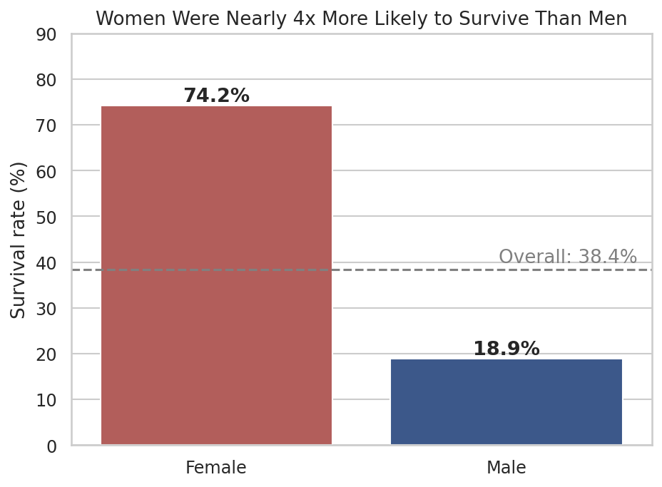
Figure 1: Survival rate by sex (dashed line = overall survival rate of 38.4%)
What it shows. Of the 314 women aboard, 74.2% survived. Of the 577 men, only 18.9% did. Women were almost four times as likely to survive as men, and the overall survival rate of 38.4% hides this huge gap.
Why this chart. A simple two-bar chart with the percentage printed on each bar gives the headline result instantly. The dashed line for the overall average gives a reference point.
Role in the story. This opens the narrative with the strongest pattern in the data. The rest of the charts ask what else mattered, and how it interacts with sex.

3.2 Chapter 2: Where on the ship? Class mattered, but sex mattered more
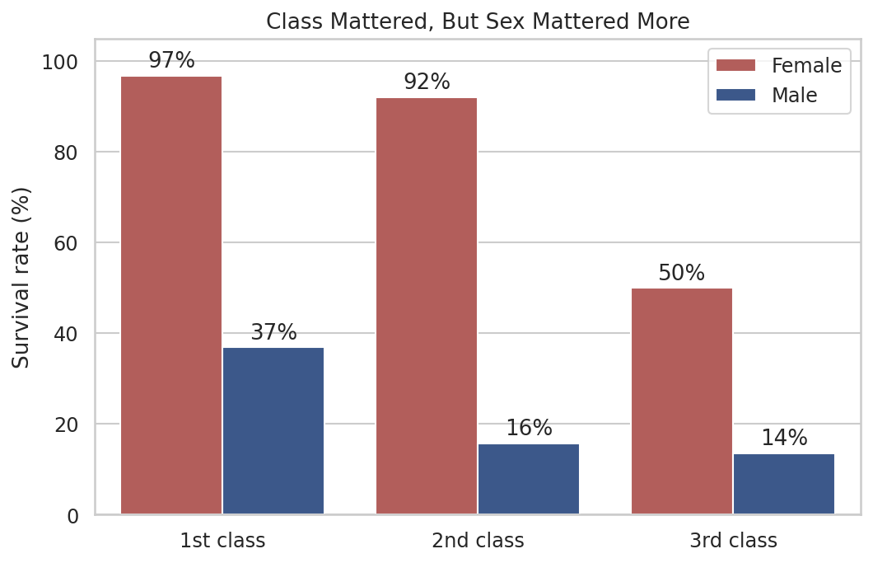
Figure 2: Survival rate by ticket class and sex
What it shows. Within every class, women survived far more often than men. In 1st class, 97% of women survived compared with 37% of men. In 2nd class the figures were 92% and 16%, and in 3rd class 50% and 14%. Class had a large effect on women (97% down to 50%) but a smaller one on men, whose survival stayed low everywhere. The comparison across groups is striking: women in 3rd class (50%) were more likely to survive than men in 1st class (37%).
Why this chart. A grouped bar chart places the two sexes next to each other inside each class, so the reader can compare across sexes and across classes in a single view.
Role in the story. This refines Chapter 1. Sex was not the only factor: ticket class strongly changed the outcome for women, but sex remained the stronger of the two overall.

3.3 Chapter 3: How old? Children had the best odds
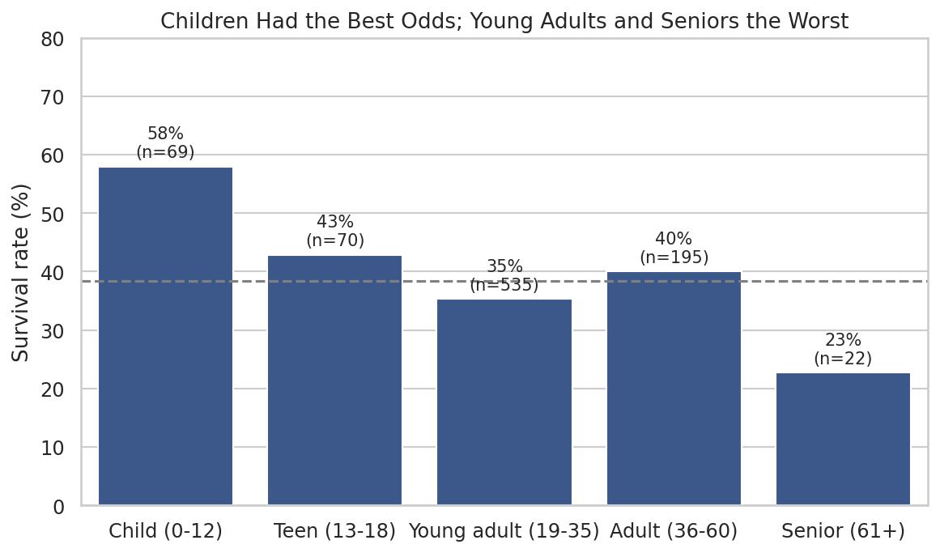
Figure 3: Survival rate by age group (n = number of passengers in the group)
What it shows. Children aged 12 and under had the highest survival rate (58%, from 69 children), followed by teenagers (43%). Young adults survived at 35% and adults aged 36 to 60 at 40%. Seniors over 60 had the lowest rate at 23%, though this group has only 22 people.
Why this chart. Grouping ages into five bands is easier to read than a scatter plot of individual ages, and labelling each bar with its group size warns the reader that the senior group is small.
Role in the story. This supports the idea that children were given priority, while showing that the effect is not smooth across ages. One caution applies: the 177 missing ages were filled with 28, which places them all in the young-adult band and makes that group larger and less precise than the others.

3.4 Chapter 4: With whom? Small families did best
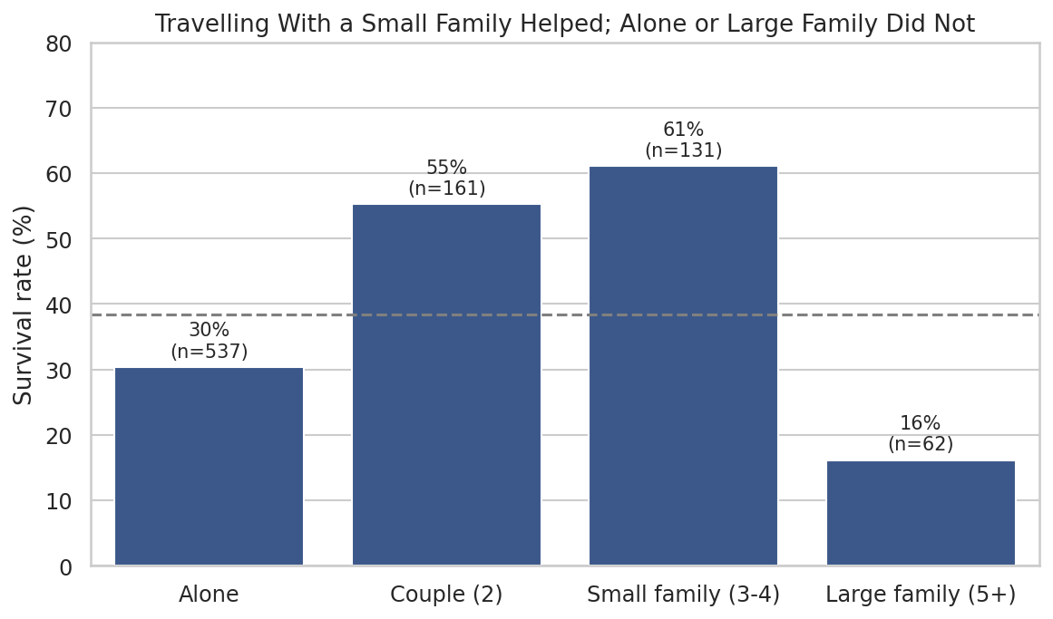
Figure 4: Survival rate by family group (n = number of passengers in the group)
What it shows. Passengers travelling alone (537 people) survived at 30%. Couples survived at 55% and small families of three or four at 61%. Large families of five or more did worst, at 16%.
Why this chart. The bars rise and then fall, showing that the relationship is not a straight line, which a single correlation number would have missed.
Role in the story. This adds a social dimension to the narrative. However, family size overlaps with the earlier factors: most solo travellers were men, and large families were mostly in 3rd class, so this chart should be read together with Charts 1 and 2 rather than as an independent cause.

3.5 Chapter 5: How much did they pay? Fares and survival
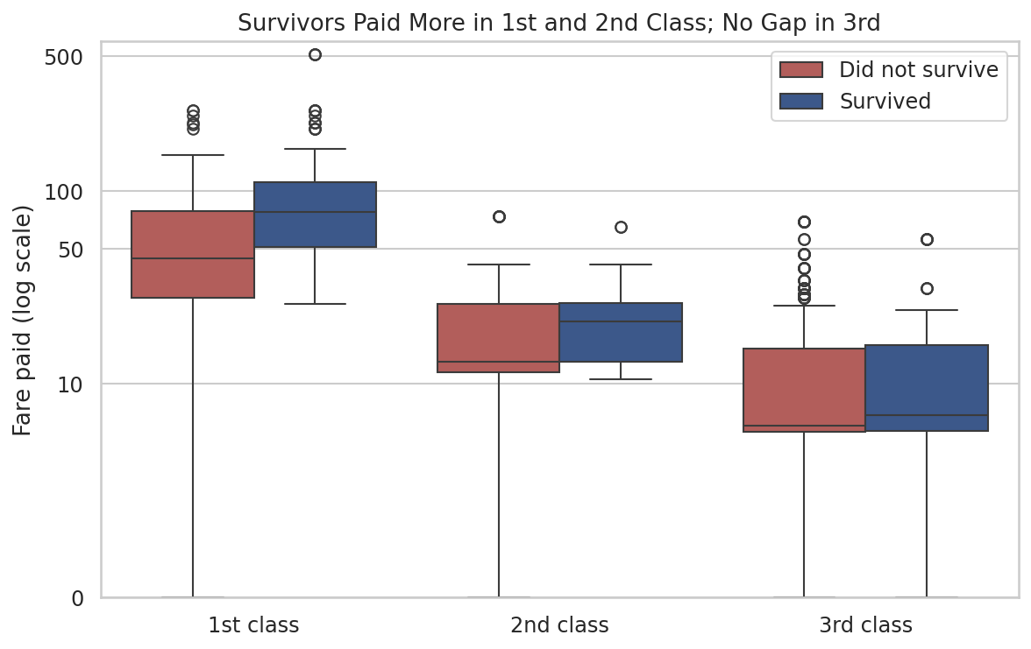
Figure 5: Fare paid by class and survival outcome (log scale)
What it shows. In 1st class, the median fare of survivors was 77.96 compared with 44.75 for non-survivors. In 2nd class the medians were 21.00 and 13.00. In 3rd class there is almost no difference (8.52 and 8.05).
Why this chart. Fares range from 0 to over 500 and are heavily skewed, so a box plot on a log scale keeps the cheap fares readable while still showing the expensive outliers. Splitting by class prevents the chart from simply repeating the fact that 1st class is expensive.
Role in the story. This shows that money mattered inside the wealthier classes: even among 1st-class passengers, those who paid more were more likely to survive, which likely reflects better cabin locations. The lack of any gap in 3rd class suggests the advantage came from cabin location and access, rather than the price itself.

3.6 Chapter 6: Putting it together
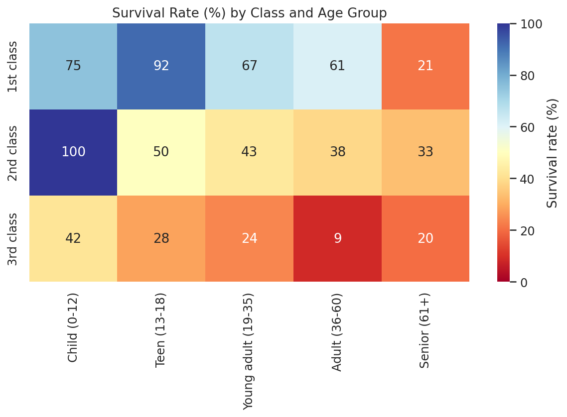
Figure 6: Survival rate (%) by ticket class and age group
What it shows. The heatmap combines two of the earlier factors. The strongest areas of survival are 2nd-class children (100%) and 1st-class teenagers (92%). The weakest are 3rd-class adults aged 36 to 60 (9%) and 3rd-class young adults (24%). Survival falls from 1st to 3rd class in almost every age band.
Why this chart. A heatmap shows 15 combinations in one compact picture, and the colour lets the reader spot the extremes without reading every number.
Role in the story. This is the summary chart. It shows that advantage stacked: being young and in a higher class was the best position, while being an adult in 3rd class was the worst. A caution applies to small cells: for example, 2nd-class children are only 17 people and 1st-class children only 4, so those percentages are less reliable.

4. The Story in Brief
- Sex was the largest divide: 74% of women survived against 19% of men.
- Class shaped the outcome, especially for women, whose survival dropped from 97% in 1st class to 50% in 3rd class.
- Children had the best chances (58%), and seniors the worst (23%).
- Small families fared best (55% to 61%), while solo travellers (30%) and large families (16%) fared worst.
- Among 1st and 2nd class passengers, survivors paid higher fares.
- These effects combined: 2nd-class children and 1st-class teenagers had the best odds, while adults in 3rd class had the worst.

5. Business and Scientific Implications

5.1 Practical implications
- Emergency planning. The Titanic shows how survival can depend on where people are and what access they have during an evacuation. Modern venues, ships, and buildings can use this lesson by making sure exits, alarms, and instructions reach every area equally, not only the most expensive or best-located ones.
- Equity in safety resources. Organizations that sell tiered services (airlines, cruise lines, event venues) should check that safety provisions do not vary with ticket price. The gap between 1st and 3rd class here is a clear example of what to avoid.
- Insurance and risk modelling. The charts show that risk is not spread evenly: it depends on combinations of factors (class and age together, for example). A risk model that treats each factor separately would miss these combined effects.
- Communication design. Family groups were split between very different outcomes. Evacuation plans should account for families and groups staying together, and give clear guidance to solo travellers.

5.2 Scientific implications
The results are a useful case study in how social norms and structure shape outcomes in a crisis. They support the historical account that priority was given to women and children, and show that this priority was applied unevenly across classes. They also suggest hypotheses for formal testing, which is the subject of the next stage of the project: whether the differences in survival by sex, class, and family size are statistically significant, and how much of each effect remains once the others are held constant.

6. Limitations
- The analysis is observational. The charts show association, not proof of cause.
- Sex, class, age, and family size overlap. For example, most solo travellers were men and most large families were in 3rd class, so no single chart isolates one factor.
- The 177 imputed ages are all set to 28, which inflates the young-adult group and slightly blurs age patterns.
- Some groups are small (seniors: 22 passengers; 1st-class children: 4), so their percentages can move a lot with one or two people.
- The dataset contains 891 of the roughly 2,200 people aboard, so the results describe this sample, not necessarily every passenger.

7. Conclusion
Six charts, arranged in order, answer the question of who survived the Titanic. Sex was the strongest single divide, ticket class strongly modified it, children were protected more than adults, small family groups fared better than solo travellers or large families, and higher fares went with better odds inside the upper classes. Taken together, the heatmap shows that these advantages stacked. Presenting the analysis as a sequence of questions, each with a chart chosen for a reason, makes the findings easier for a non-technical reader to follow than a set of separate plots. The next stage is to test these patterns statistically to see which differences are unlikely to be due to chance.

Appendix: Complete Python Script
The script below reproduces every figure and number in this report. It requires Titanic-Dataset.csv in the same folder as the script, and the pandas, numpy, seaborn, and matplotlib libraries.
import os
os.chdir(os.path.dirname(os.path.abspath(__file__)))

import pandas as pd
import numpy as np
import seaborn as sns
import matplotlib
import matplotlib.pyplot as plt

sns.set_theme(style='whitegrid', font_scale=1.05)
PALETTE = {'Did not survive': '#C0504D', 'Survived': '#2F5597'}

# ---------- 1. LOAD + CLEAN (same steps as Week 1) ----------
df = pd.read_csv('Titanic-Dataset.csv')
df['Age'] = df['Age'].fillna(df['Age'].median())
df['Embarked'] = df['Embarked'].fillna(df['Embarked'].mode()[0])
df = df.drop(columns=['Cabin']).drop_duplicates()

# ---------- 2. FEATURE ENGINEERING FOR THE STORY ----------
df['Outcome'] = df['Survived'].map({0: 'Did not survive', 1: 'Survived'})
df['Class'] = df['Pclass'].map({1: '1st class', 2: '2nd class', 3: '3rd class'})
df['Sex'] = df['Sex'].str.capitalize()
df['AgeGroup'] = pd.cut(df['Age'], bins=[0, 12, 18, 35, 60, 100],
labels=['Child (0-12)', 'Teen (13-18)', 'Young adult (19-35)',
'Adult (36-60)', 'Senior (61+)'])
df['FamilySize'] = df['SibSp'] + df['Parch'] + 1
df['FamilyGroup'] = pd.cut(df['FamilySize'], bins=[0, 1, 2, 4, 20],
labels=['Alone', 'Couple (2)', 'Small family (3-4)', 'Large family (5+)'])

# ---------- 3. VISUALIZATIONS ----------
# Viz 1: survival rate by sex
rate_sex = df.groupby('Sex')['Survived'].mean().mul(100).reset_index()
plt.figure(figsize=(7, 5))
ax = sns.barplot(x='Sex', y='Survived', data=rate_sex, palette={'Female': '#C0504D', 'Male': '#2F5597'}, hue='Sex', legend=False)
for p in ax.patches:
ax.annotate(f'{p.get_height():.1f}%', (p.get_x() + p.get_width() / 2, p.get_height()),
ha='center', va='bottom', fontsize=13, fontweight='bold')
ax.axhline(df['Survived'].mean() * 100, color='grey', linestyle='--')
ax.text(1.45, df['Survived'].mean() * 100 + 1.5, 'Overall: 38.4%', ha='right', color='grey')
plt.title('Women Were Nearly 4x More Likely to Survive Than Men')
plt.ylabel('Survival rate (%)'); plt.xlabel('')
plt.ylim(0, 90)
plt.savefig('w2_viz1_survival_by_sex.png', dpi=150, bbox_inches='tight'); plt.close()

# Viz 2: class x sex
rate_cs = df.groupby(['Class', 'Sex'])['Survived'].mean().mul(100).reset_index()
plt.figure(figsize=(8, 5))
ax = sns.barplot(x='Class', y='Survived', hue='Sex', data=rate_cs, palette=['#C0504D', '#2F5597'],
order=['1st class', '2nd class', '3rd class'], hue_order=['Female', 'Male'])
for c in ax.containers:
ax.bar_label(c, fmt='%.0f%%', padding=2)
plt.title('Class Mattered, But Sex Mattered More')
plt.ylabel('Survival rate (%)'); plt.xlabel('')
plt.ylim(0, 105); plt.legend(title='', loc='upper right')
plt.savefig('w2_viz2_class_by_sex.png', dpi=150, bbox_inches='tight'); plt.close()

# Viz 3: age group
rate_age = df.groupby('AgeGroup', observed=True)['Survived'].agg(['mean', 'count']).reset_index()
rate_age['mean'] *= 100
plt.figure(figsize=(9, 5))
ax = sns.barplot(x='AgeGroup', y='mean', data=rate_age, color='#2F5597')
for i, r in rate_age.iterrows():
ax.text(i, r['mean'] + 1, f"{r['mean']:.0f}%\n(n={int(r['count'])})", ha='center', va='bottom', fontsize=10)
ax.axhline(df['Survived'].mean() * 100, color='grey', linestyle='--')
plt.title('Children Had the Best Odds; Young Adults and Seniors the Worst')
plt.ylabel('Survival rate (%)'); plt.xlabel('')
plt.ylim(0, 80)
plt.savefig('w2_viz3_survival_by_age_group.png', dpi=150, bbox_inches='tight'); plt.close()

# Viz 4: family size
rate_fam = df.groupby('FamilyGroup', observed=True)['Survived'].agg(['mean', 'count']).reset_index()
rate_fam['mean'] *= 100
plt.figure(figsize=(9, 5))
ax = sns.barplot(x='FamilyGroup', y='mean', data=rate_fam, color='#2F5597')
for i, r in rate_fam.iterrows():
ax.text(i, r['mean'] + 1, f"{r['mean']:.0f}%\n(n={int(r['count'])})", ha='center', va='bottom', fontsize=10)
ax.axhline(df['Survived'].mean() * 100, color='grey', linestyle='--')
plt.title('Travelling With a Small Family Helped; Alone or Large Family Did Not')
plt.ylabel('Survival rate (%)'); plt.xlabel('')
plt.ylim(0, 80)
plt.savefig('w2_viz4_survival_by_family.png', dpi=150, bbox_inches='tight'); plt.close()

# Viz 5: fare by class and outcome (log scale)
plt.figure(figsize=(9, 5.5))
sns.boxplot(x='Class', y='Fare', hue='Outcome', data=df, order=['1st class', '2nd class', '3rd class'],
hue_order=['Did not survive', 'Survived'], palette=PALETTE)
plt.yscale('symlog', linthresh=10)
plt.yticks([0, 10, 50, 100, 500], ['0', '10', '50', '100', '500'])
plt.ylim(0, 600)
plt.title('Survivors Paid More in 1st and 2nd Class; No Gap in 3rd')
plt.ylabel('Fare paid (log scale)'); plt.xlabel(''); plt.legend(title='')
plt.savefig('w2_viz5_fare_by_class_outcome.png', dpi=150, bbox_inches='tight'); plt.close()

# Viz 6: heatmap class x age group
heat = df.pivot_table(index='Class', columns='AgeGroup', values='Survived', aggfunc='mean', observed=True) * 100
plt.figure(figsize=(9.5, 4.5))
sns.heatmap(heat, annot=True, fmt='.0f', cmap='RdYlBu', vmin=0, vmax=100,
cbar_kws={'label': 'Survival rate (%)'})
plt.title('Survival Rate (%) by Class and Age Group')
plt.xlabel(''); plt.ylabel('')
plt.savefig('w2_viz6_heatmap_class_age.png', dpi=150, bbox_inches='tight'); plt.close()

# ---------- 4. NUMBERS FOR THE WRITE-UP ----------
print(rate_sex.round(1)); print(rate_cs.round(1)); print(rate_age.round(1)); print(rate_fam.round(1))
print(heat.round(0))
print(df.groupby(['Class','Outcome'])['Fare'].median().round(2))
print(df['Sex'].value_counts()); print(df['Class'].value_counts())
print("Children n:", (df.AgeGroup=='Child (0-12)').sum())
print(pd.crosstab(df['Class'], df['Sex']))

